**Lab – 20: Sign-in activity reports in the Azure Active Directory.**

**Objective:** The objective of this lab is –

* To view sign-in activity reports in the Azure Active Directory.

With Azure Active Directory (Azure AD) reporting in the Azure portal, you can get the information you need to determine how your environment is doing. Sign-in activities provide you Information about the usage of managed applications and user sign-in activities. With the information provided by the user sign-in report, you find answers to questions such as: What is the sign-in pattern of a user, how many users have users signed in over a week? And What’s the status of these sign-ins?

**Prerequisite:** EMS Enterprise Mobility + Security E5.

**Steps:**

1. Sign in to your Azure Portal, by using the link - **https://portal.azure.com/**. Enter your credentials and click Sign In.

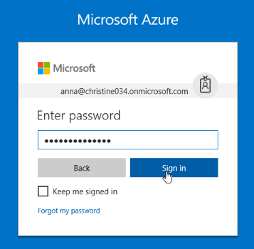

1. Microsoft Azure AD Dashboard will open.

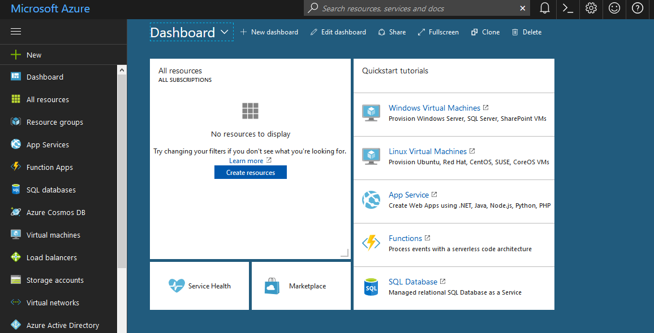

1. Now click **Azure Active Directory** from left-hand pane, and then select **Sign-ins** under **Activity** section.

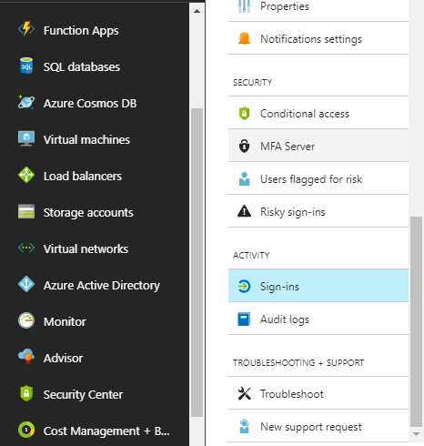

1. An audit log has a default list view that shows: the related user, the application that user has signed-in to, the sign-in status, the sign-in time, MFA required etc.

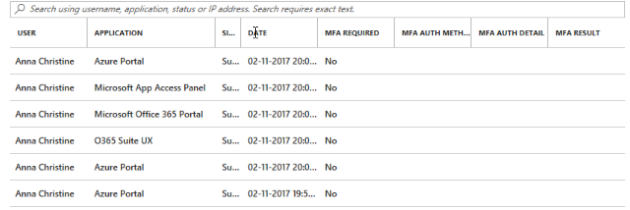

1. You can customize the list view by clicking **Columns** in the toolbar. This enables you to display additional fields or remove fields that are already displayed. Here, uncheck MFA Required, MFA Auth Method, MFA Auth Detail and MFA Result. And, check IP address to view IP Address of the logged in machine. Then click **Apply**.



1. Now you can see the sign-in report according to your selected columns.

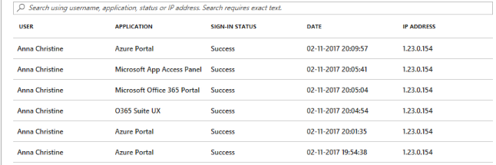

1. To narrow down the reported data to a level that works for you, you can filter the sign-ins data using the fields: Date, User, Application, Client and Sign-in status.

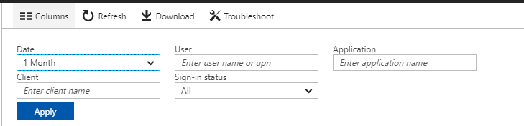

1. The **Date** filter enables to you to define a timeframe for the returned data. Possible values are: 1 month, 7 days, 24 hours and Custom. When you select a custom timeframe, you can configure a start time and an end time. The **user** filter enables you to specify the name or the user principal name (UPN) of the user you care about. The **application** filter enables you to specify the name of the application you care about. The **client** filter enables you to specify information about the device you care about. And, the **sign-in status** filter enables you to select one of the filter: All, Success and Failure.

Here, Select 🡪 **Date:** 7 days, **User:** Anna Christine, **Application:** Azure Portal, **Client:** (Leave blank) and **Sign-in status:** All. And, click **Apply**. After applying you can see the report will show only the filtered data.

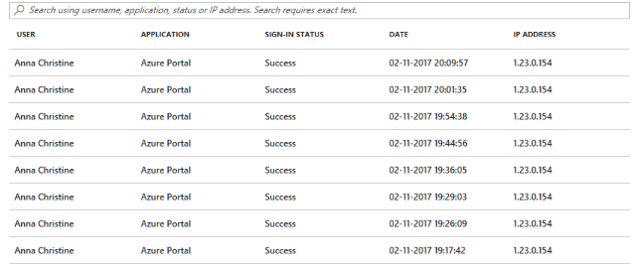

1. By clicking an item in the list view, you get all available details about it.

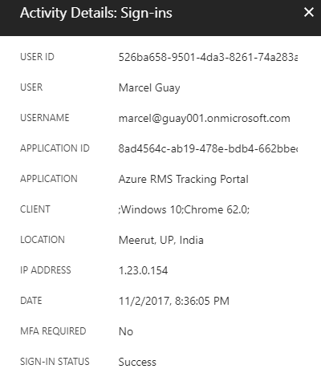

1. Also, you can download the report in your machine by clicking **Download** in the toolbar.



1. So, this is how you can view sign-in activity reports in the Azure Active Directory.